**Experimental Analysis of Vapor Compression Refridgeration Cycle Expansion Valves**

Christopher R. White

MWG: David Bedding, Jorge Godoy, Samuel Hordeski, Kevin Myers, Justin Sandler

Department of Mechanical Engineering

Lafayette College

Easton, PA 18042

**Abstract**

Refrigeration is a cyclic process in which heat is drawn from a region of low temperature and transferred to one of higher temperature. The study of thermodynamics is essential in the design of refrigeration systems, since both the mechanical components and the working fluid have a significant effect on the performance of the overall cycle. The purpose of this experiment was to characterize the operation and performance of the Hampden Refrigeration Trainerby varying the pressure drop through 3 expansion valves in order to determine the optimal valve using R134a. This was accomplished by monitoring the temperature, pressure, and mass flow rate between components while running the system with a thermostatic expansion valve (TEV), capillary tube (CT), and hand expansion valve (HEV). Using the first law of thermodynamics, the coefficients of performance (CoP) for the ideal and actual refrigerator cycles. The HEV was used to explore the effect of flow rate on CoP at mass flow rates between 1.86±0.364 and 4.77±0.362 g/s resulting a linear trend with CoP values of 3.04±0.13 and 1.62±0.06 respectively.Itwas determined the HEV is the most optimal valve at flow rates below 4.77g/s where the compressor efficiency decreased, making it not an ideal valve in residential or commercial buildings. Therefore it was concluded that the TEV valve is optimal for use in commercial buildings with an actual CoP of 2.26±0.09 due to the temperature regulating system feedback control. The CT valve is most optimal for residential refrigeration with actual CoP of 2.10±0.09 since it is compact, inexpensive, and maitinince-free.

**Introduction and Methods**

In 1987, the Montreal Protocol began the worldwide phase-out of ozone-depleting refrigerants in favor of ozone-friendly refrigerants, driving refrigeration system manufacturers to develop equipment that run efficiently using these refrigerants with less favorable thermodynamic properties [1]. One of the most efficient, reliable, and inexpensive cycles is the vapor compression refrigeration (VCR) cycle (shown schematically in Figure 1), in which the refrigerant is vaporized, compressed, and condensed [2]. Unlike other refrigeration cycles, the ideal VCR cycle is not internally reversible due to the addition of the expansion valve, which makes it a realistic model for the analyzing the actual VCR cycle.The ideal cycle can be analyzed using the first law of thermodynamics, expressed as

$Q-W= ∆U$ ⑴

where $Q$ is heat transfer, $W$ is the work, and $∆U$ is the change in internal energy. It is assumed that internal energy is negligible within the system, therefore there are no changes in internal energy. The first law of thermodynamics is used to analyze the effects of the components on the working fluid even though the second law of thermodynamics states that heat flow from cold to hot temperature is impossible. The VCR cycle accomplishes this task by performing work on the vaporized refrigerant by increasing the pressure of the working fluid via compressor.

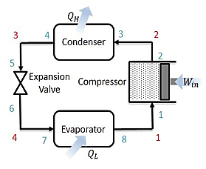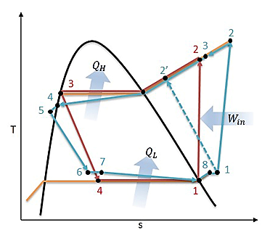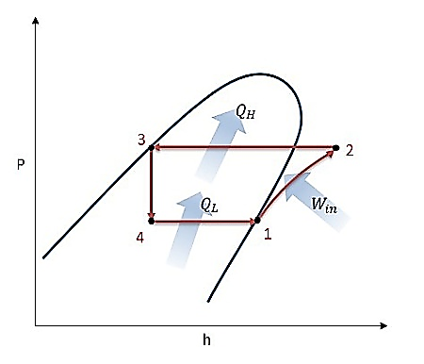

**Figure 1: (a) Schematic, and (b) Temperature-Entropy and (c) Pressure-Enthalpy Diagrams for Ideal (red) and Actual (blue) VCR Cycle**

The ideal VCR cycle begins with saturated refrigerant vapor entering the compressor at state 1, increasing in pressure and temperature through an isentropic process in Figure 1. Using Eq. (1), compressor work is expressed as

$W_{net,in}= \dot{m}(h_{2}- h_{1})$ ⑵

where $W_{net,in}$ the compressor work into the system is, $\dot{m}$ is the mass flow rate, and $h$ is the enthalpy at each state. Upon exiting the compressor, the superheated refrigerant enters the condenser at stage 2, which releases heat to the cooler surroundings as the refrigerant is liquefied isobarically. Using Eq. (1), the heat exiting the system is expressed as

$Q_{H}= \dot{m}(h_{2}-h_{3})$ ⑶

where $Q_{H}$ is the heat transferred from the refrigerant to environment, $\dot{m}$ is the mass flow rate, and $h$ is the enthalpy at each state. The saturated liquid refrigerant enters the expansion valve at stage 3 where it undergoes an abrupt decrease in pressure isenthalpically. During the adiabatic flash evaporation, some of the refrigerant vaporizes resulting in an auto-refrigerated mixture.The mixture enters the evaporator at stage 4, which transfers heat into the refrigerant from the warm air of the space being refrigerated isobarically and results in a saturated vapor. Using Eq. (1), the heat entering the refrigeration system is expressed as

$Q_{L}= \dot{m}(h_{1}-h_{4})$ ⑷

where $Q_{L}$ is the heat transferred into the refridgerant from the environment, $\dot{m}$ is the mass flow rate, and $h$ is the enthalpy at each state. The refrigerant leaves the evaporator as a saturated vapor and reenters the compressor, completing the cycle. The performance of the cycle is characterized by the CoP, which is the ratio between the desired output heat transfer and the work required to run the compressor and is expressed as

${COP}_{R}=\frac{Q_{L}}{W_{net,in}}$ ⑸

where $Q_{L}$ and $W_{net,in}$ are determined using Eq. (2) & Eq. (3) respectively. CoP is significantly influenced by the mass flow rate of the refrigerant, which is controlled by the throttling valve. The TEV, CT, and HEV are unique designs that control the flow rate with different physical mechanisms resulting in dissimilar CoP values due to the variation in pressure drops.

The TEV contains a temperature sensitive bulb filled with a gas of similar properties to the refrigerant and controls mass flow rate based on the temperature of the refrigerant monitored at the exit of the evaporator. The gas works against the force of a spring as the pressure increases or decreases to open or restrict the mass flow rate through the valve until the system reaches steady state operation.

The CT is a non-adjustable constant area expansion device that comprises of a long tube with small inner diameter and is coiled several times to reduce space. It induces a pressure drop due to the frictional forces between the refrigerant and the inner tube wall. The pressure drop attained depends on diameter and length accompanied by large drop in temperature

The HEV is designed as a manually operated throttling device that controls flow into the evaporator through the seat via the height of the needle. The height is controlled by the adjustment screw, which is manually operated by the user, who specifies the mass flow rate of the cycle.

In the current study, the actual CoP was experimentally determined for 3 throttling valves and compared to the theoretical CoP in order to determine the optimal valve for the VCR cycle.

The experiments were performed on the Hampden Refrigeration Trainer, by running the cycle in forward mode while measuring the temperature, pressure, and mass flow rate at specific points in the cycle. The actual CoP was experimentally determined for the TEV, CT, and HEV control by using the first law of thermodynamics. The air conditioning instrumentation locations are displayed on a schematic of the actual cycle in Figure 2.

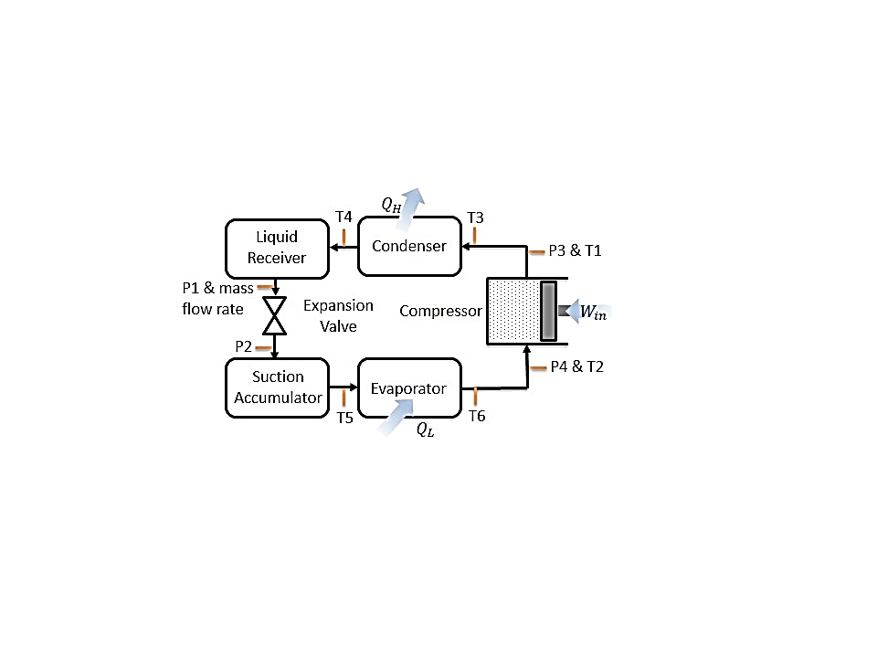**Results and Discussion**

**Figure 2: Hampden Refrigeration Trainer Schematic with Instrumentation Locations: Type-T Thermocouples, Sho-Rate "50" Model 1350E Flowmeter, and Pressure Transducers**

Three experimental set ups were considered: (1) Cooling (FWD) mode with TEV control, (2) Cooling (FWD) mode with CT control, and (3) Cooling (FWD) mode with HEV control at mass flow rates between 1.86 – 4.77 g/s.

For the TEV control arrangement, the system was prepared according to the startup procedure in the Operating Instructions at a laboratory temperature of 24˚C [3]. Temperature, pressure, and mass flow rate were measured at the locations displayed in Figure 2. Each measurement was recorded 3 times in intervals of 5 minutes in order to confirm that the system had reached steady state as gauge fluxuations were minimal. At a mass flow rate of 3.62±0.363 g/s, the actual CoP for TEV control was 2.26±0.09 determined using Eq. (5) displayed in Figure 3.

The effects of CT control was set up by opening the CTV and closing the TEV-1 in Figure 2. Temperature, pressure, and mass flow rate were measured 3 times at the locations displayed in Figure 2. At a mass flow rate of 4.31±0.362 g/s, the actual CoP for CT control was 2.10±0.09 determined using Eq. (5) displayed in Figure 3.

HEV control was established by slightly cracking the HEV and closing the CTV and the system was tested by adjusting the HEV to produce flow rates of 1.86±0.364, 3.39±0.363, and 4.77±0.362 g/s. Temperature, pressure, and mass flow rate were measured at the locations displayed in Figure 2 at each flow rate. The actual HEV CoP values for each flow rate were 3.04±0.13, 2.63±0.11, and 1.62±0.06 respectfully determined using Eq. (5) displayed in Figure 3.



**Figure 3: (a) Pressure-Enthalpy and (b) Temperature-Entropy Diagrams for Ideal (red) and Actual (blue) VCR Cycle Processed in MATLAB with CoolProps  
AT**

While the VCR cycle is a realistic model of the actual cycle, there are differences between 3 of the stages due irreverabilities occurring throughout the refrigeration system. The two significant sources of irreversabilites are piping losses and unwanted heat transfer with the environment, the effects of which are displayed in Figure 3. Piping losses have a minimal effect on the cycle occurring in the condenser (stages 3 to 4) and the evaporator (stages 7 to 8.) They are a result of fluid friction against the inner surface of the piping and components under the no slip boundary condition. As mass flow increases, heat lost and gained increases as shown in Table 1.The most significiant source of irreversibility occurs in the compression process due to entropy generation from friction between the vapor and the interior of the pump. Unlike the ideal isentropic process, the actual VCR cycle compressor significantly increases temperature of the vapor resulting in entropy generation due to the friction and heat transfer. In Table 1, compressor efficiency increased with mass flow rate, with the exception of the HEV at 4.77g/s, which was due to the high vapor mass flow forcing the compressor to apply significanltly more work resulting in a low efficiency in comparison to the ideal compression process.

|  |  |  |  |
| --- | --- | --- | --- |
|  | Heat Lost (W) | Heat Gained (W) | Compressor Efficiency |
| TEV | 504.2 | 727.3 | 0.292 |
| CT | 548.0 | 809.0 | 0.453 |
| HEV1 | 304.3 | 404.4 | 0.120 |
| HEV2 | 500.0 | 690.4 | 0.211 |
| HEV3 | 607.9 | 984.2 | 0.333 |

Other differences between the actual and ideal cycle include refrigerant leaving the evaporator as a saturated vapor and entering the compressor as at the same quality in the ideal cycle. In the actual cycle, the refrigerant may degrade in quality resulting in condensation entering and damaging the compressor. Therefore actual refrigeration systems add a few extra degrees of super heat to the refrigerant in the evaporator in order to superheat the refrigerant vapor to ensure that the refrigerant is fully vaporized thoughout the compression process. In addition to the superheating process, a component called a suction accumulator is located between stages 8 and 1, which ensures that no condensed liquid enters the compressor by separating the condensed liquid from the superheated vapor. Accumulators have a metering ejector device that vaporizes the liquid built up in the reservoir.

In the ideal system refridgerant enters the expansion valve as a saturated liquid after leaving the condenser. However this may not be the case in the actual cycle due to the pressure drop between stages 3 and 4 due piping losses from friction. **It is undesirable to have a mixture entering the throttling valve, because of the lower entry enthalpy, therefore the refrigerant passes through the liquid receiver at stages 4 to 5, ensuring that only a saturated liquid enters the valve.** It serves as a seal against the entrance of vapor refrigerant entering the liquid line by accumulating liquid refrigerant and ensures the availability of stored refridgerant until the system requires it.

**Comparison between the ideal VCR cycle and actual VCR cycle COP error bars therefore justify validity of the VCR cycle as a model for the actual cycle.**

**Irreverabilities have a negative effect on performance and therefore the actual CoP decreases and compressor efficiency decreases due to the high mass flow rate entering the compressor. Increasing entropy gerneration due to friction because the compressor has to work harder.** **Despite the irreversabilities, the ideal VCR cycle is a valid model for the actual cycle due to the CoP values displayed in Figure 4, since error bars of the actual CoP values are very similar to the position of the ideal values.**

**The most signicficant losses occur in the compressor. Examine the comperessor efficiency compare compressor efficiency error**

**Behavior of TEV and CT control using HEV results to support your conclusions**

Based on Figure 4 it is displayed that CoP decreases with increasing mass flow rate. HEV control at a flow rate of 1.86 g/s results in a high CoP **very little heat transfer leaving the system compared to the work being input into the system to run the compressor due to the low amount of mass flow rate which absorbs the heat from the environment. At high flow rates at 4.77 g/s, there is such a high flow rate that not enough heat gets absorbed by the refrigerant. Thus concluding that at very low and very high flow rates CoP is negatively affected.**

The results from the 3 HEV experiments displayed a decreasing linear relationship between the CoP and mass flow rate. **As mass flow rate decreases, cooling power decreases, requiring less compressor work thus increasing CoP. Lower compressor work is a result of the refrigerant entering the compressor at a higher super-heated vapor. This decreases the difference between the enthalpies at the beginning and end of compressor requiring less work according to Eq. (2). The low mass flow rate means that the refrigerant is capable of absorbing heat at the evaporator and dispersing heat at the condenser occurs relatively easily and efficiently. Higher mass flow rate results in not all of the refrigerant absorbing heat in the evaporator quickly, and results in the refrigerant not discarding heat in the condenser.**

HEV1

**Resulted in a very high temperature of 299.3K at the entrance to the compressor. And compressor exit temperature of 369.8K. and expansion tube entry point of 314.8 K and exit of 269.2 K. significantly different from TEV and CT**

HEV2

**Resulted in a very high temperature of 297K at the entrance to the compressor. And compressor exit temperature of 370.4K. Most similar to TEV**

HEV3

**Resulted in a very high temperature of 283.7K at the entrance to the compressor. And compressor exit temperature of 379.8K. Most similar to CT**

**TEV control**

**TEV control essentially forces the system to operate at equilibrium based on the refrigerant temperature at the exit of the evaporator. Resulted in a high temperature of 290.4 K at the entrance to the compressor. And compressor exit temperature of 369.8K.**

TEV control results in a CoP that is slightly higher than that of CP control, which is attributed to the mechanics of TEV control, because low rate is controlled through a mechanical feedback loop based on the refrigerant temperature at the evaporator exit. Therefore the valve wants to achieve the steady state mass flow rate for the system based on the temperature of the system.

**CT control**

**CT control essentially forces the system to operate based on the geometry of the tube Resulted in a low temperature of 282 K at the entrance to the compressor. Dropping in temp and increasing in entropy in the suction accumulator .And compressor exit temperature of 362K.**

**Conclusions**

The purpose of this experiment was characterize the performance of the refrigeration system by determining the effect of TEV, CT, and HEV control on the VCR cycle. **Though the first law of thermodynamics the CoP was determined for the actual and ideal cycles for each expansion valve. The CoP error bars between the ideal and the actual cycles were similar and therefore the VCR ideal model was accurate for modeling the actual cycle. Based on the experiments it was determined that HEV control was the optimal control device due to its high CoP at low flow rates. Based on the HEV experiments, it was determined that TEV control was optimal for commercial refrigeration with a CoP of __±___. Whereas due to the compact size and low cost of the CT, it was best suited for use in residential refrigeration systems. With a CoP of __±___.**

**References**

1. <http://www.epa.gov/ozone/title6/phaseout/22phaseout.html>
2. Ҫengel, T.A. and Boles, M.A. (2002) *Thermodynamics: An Engineering Approach,* McGraw Hill, 4th Edition.
3. Rossmann, T., Sabatino, D. & Utter B. (2015). *ME 475: Refrigeration System Laboratory Description*. Easton, PA: Lafayette College.

**Advantages of the Capillary Tube**

Here are some of the advantages of using capillary tube as the throttling device in the refrigeration and the air conditioning systems:

1) The capillary tube is a very simple device that can be manufactured easily and it is not very costly.

2) The capillary tube limits the maximum amount of the refrigerant that can be charged in the refrigeration system due to which the receiver is not required in these systems.

3) When the refrigeration plant stops the pressure across the capillary tube becomes same and also along the whole refrigeration cycle the pressure is constant. This means that when the plant is stopped the pressure at the suction and discharge side of the compressor are same. Thus when the compressor is restarted there is not much load on it since it does not have to overcome very high pressures. Due to this the compressor motor of smaller torque can be selected for driving the compressor, thus reducing the cost of the compressor. This along with the above two advantages helps reducing the overall cost of the refrigeration and the air conditioning systems.

<https://www10.informatik.uni-erlangen.de/Teaching/IGWA/2013/report/course1/pdfs/04_IITR_SSS.pdf>

The heat transfers occurring between the refrigerant and the hot and cold regions are not reversible. Since the refrigerant temperature in the evaporator is less than the cold reservoir temperature and the refrigerant temperature in the condenser is greater than the temperature of the hot reservoir.

**Due to the irreversible throttling process in which the temperature and pressure decrease at constant enthalpy, the refrigerant enters the evaporator at state 3 as a low-quality mixture. Pressure drops below saturation, part of refrigerant flashes from liquid phase to vapor phase.**

Capillary

- due to the large exposed surface area heat transfer may be significant

Less mass flow: expansion tube is not working properly, resuling in super heated vapor. Not getting enough mass flow. As a rresul the compressor efficiency increases

Increasing mass flow rate,